Manage Virtual Machines Student

Task 1:

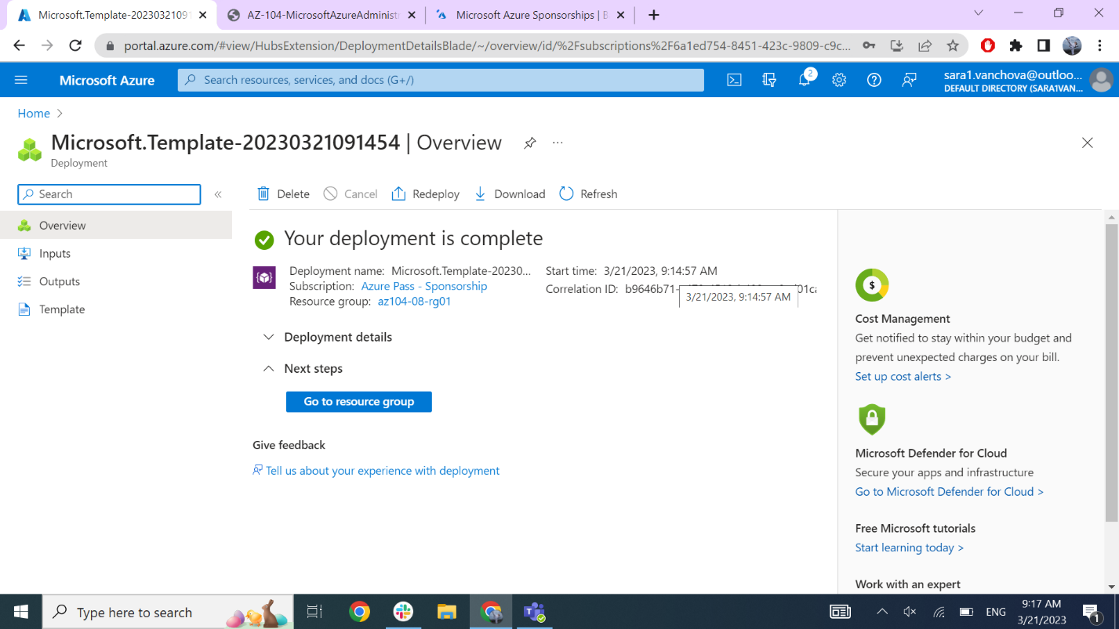

Task 2:

Task 3:

Task 4:

Task 5:

Task 6:

108.142.245.1 (az10408vmss0-ip) - Public IP

Task 7

